VEDAS COLLEGE
Jawalakhel, Lalitpur, Nepal.
(Affiliated to Tribhuvan University)


Laboratory Report of Computer Networks
(CSC263)

Submitted By:- Submitted To:-
Name:- Prajwal Chaulagain Instructor:- Indra Chaudhary
Roll No:- 28
Semester:- Fourth
Faculty:- Science and Technology
Level:- Bachelor
Program:- Bachelors of Science in Computer Science and Information Technology.

August, 2025
CN Laboratory Assignment Log Sheet 2025

Name:- Prajwal Chaulagain Roll No:- 28

Task  No. | Title | Signature
General
1 | Identify cable standards. Create and Test cross – over and straight through cables.
2 | Create a basic network and share file and folders.
Cisco Packet Tracer (RS – IPv4)
3 | Installing Cisco Packet Tracer.
4 | Creating a Peer-to-Peer Network.
5 | Implement the LAN topologies.
6 | Creation of VLAN.
7 | Creation of VLAN Trunking.
8 | Implementation of Static Routing configuration.
9 | Implementation of dynamic routing (RIP) configuration.
10 | Implementation of dynamic routing (OSPF) configuration.
11 | Configure DNS, DHCP, FTP and Web Server.
Linux Machine (CentOS)
12 | Cent OS 9 (server/client) installation over VMware.
13 | Linux Fundamentals.
14 | User, Groups, Permission.
15 | Firewall Configuration.
16 | Network Configuration (Static and Dynamic).
17 | Apache Web Server Configuration.

Cisco Packet Tracer (Routing and Switching – IPv4)

Task 3:- Installing Cisco Packet Tracer.
Introduction:-
Cisco Packet Tracer is a simulation tool used to design and test computer networks without real hardware. It is widely used by students to practice networking concepts.

Aim:-
To install Cisco Packet Tracer on the computer.

Steps:-
i. Download Packet Tracer from the official website of Netacad.
ii. Check for the executable file and run it.
iii. Next screen is of License Agreement so Click on I accept the license.
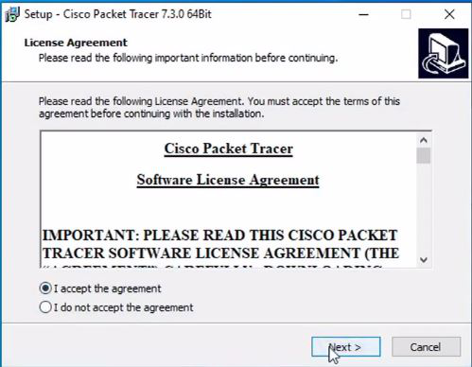

iv. Select the start menu folder and click the Next button.
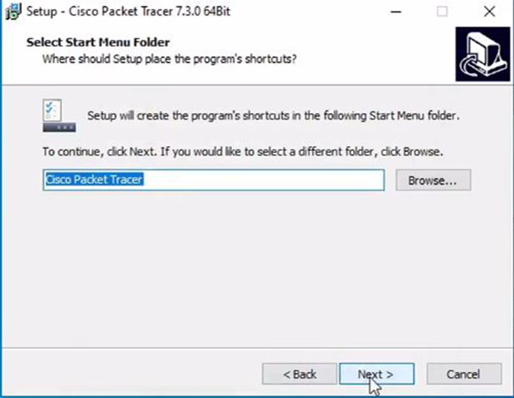

v. Now packet tracer is ready to install so click on the Install button.
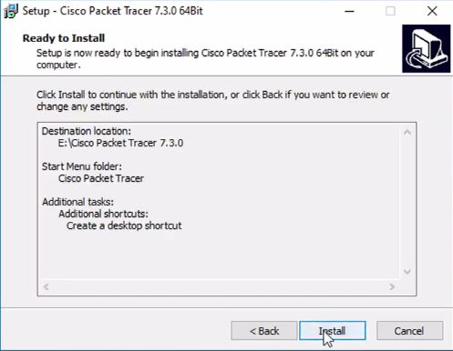

vi. The installation process will start and will hardly take a minute.
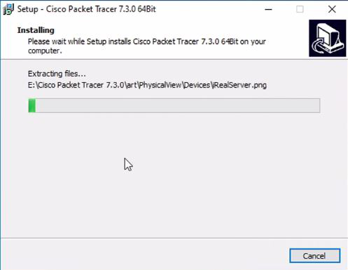

vii. Click on the Finish button to complete the installation.
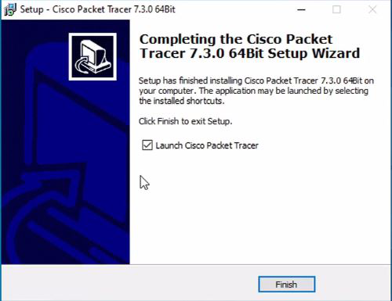

Result:-
Cisco Packer Tracer was installed successfully and is ready to create and test network topologies.
Task 4:- Creating a Peer-to-Peer Network.
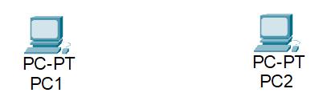

Equipment needed
  - 2 Workstations
  - 1 Ethernet cable

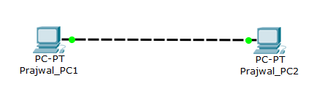
- Identify the cable (straight through, cross over or rollover) and connect the workstations i.e., PC1and PC2.

b) Configure the layer 3 address to the workstations.
- PC1→ 192.168.1.2/24
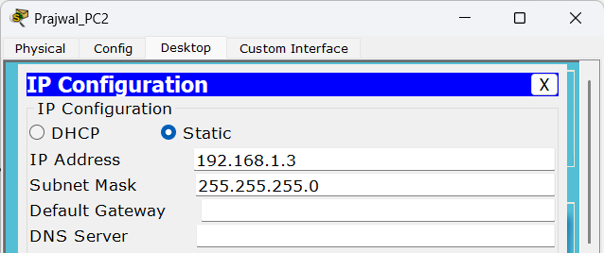
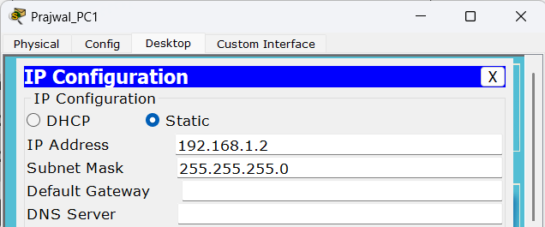
- PC2→ 192.168.1.3/24

c) Verify Connectivity (ping command)
- Ping PC2 (192.168.1.3) from PC1 (192.168.1.2)
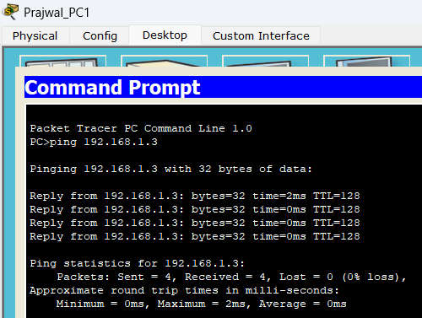

Task 5:- Implement the LAN topologies.
5.1 Star Topology
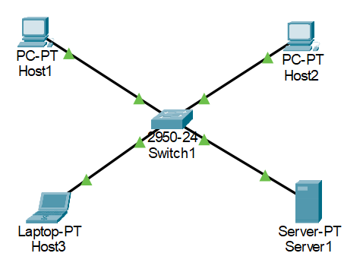

Addressing Table
Device | Interface | IPv4 Address | Subnet Mask
Host1 | NIC | 192.168.10.101 | 255.255.255.0
Host2 | NIC | 192.168.10.102 | 255.255.255.0
Host3 | NIC | 192.168.10.103 | 255.255.255.0
Server1 | NIC | 192.168.10.104 | 255.255.255.0

a) Design the given topology.
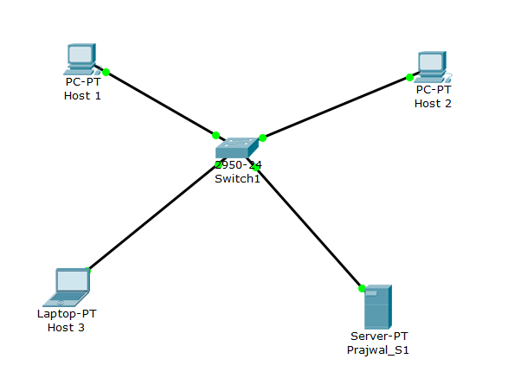

b) Configure the layer 3 address to all nodes according to addressing table.
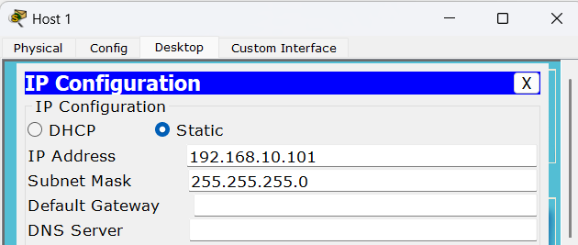

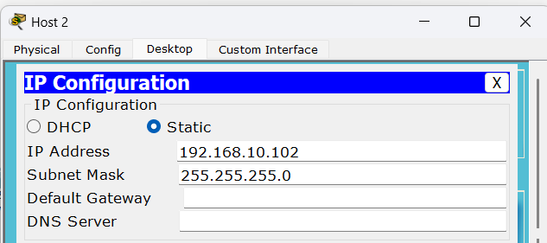

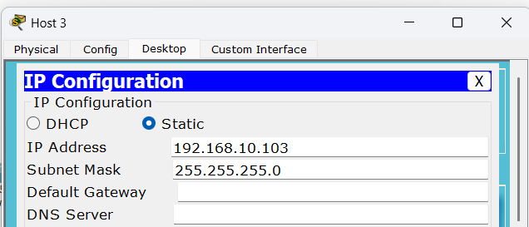

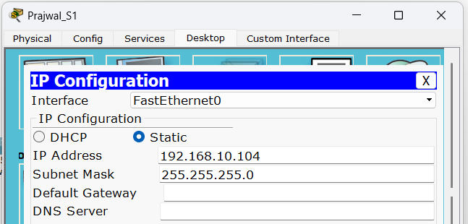

c) From the command prompt on each node, run the ping test and write the output.
- Can Host1 ping Server1?
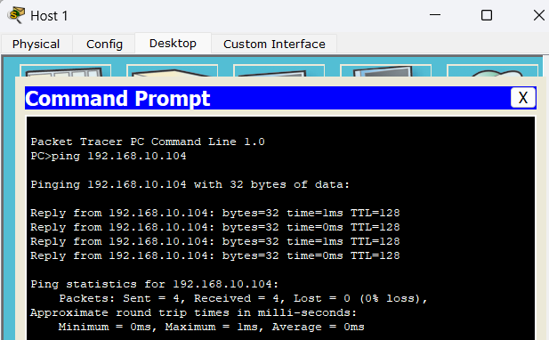

- Can Server1 ping Host3 and Host2?
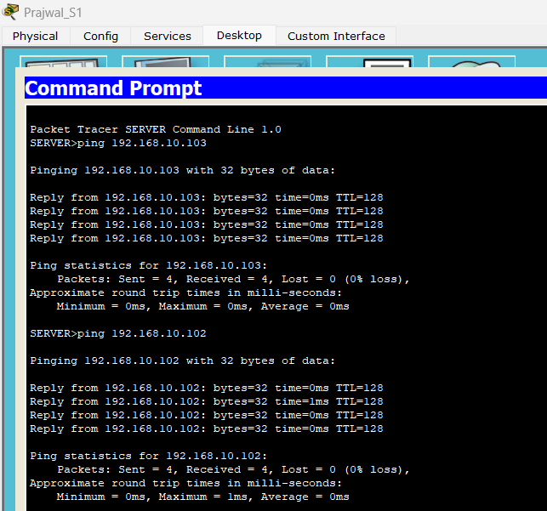

5.2 Bus Topology
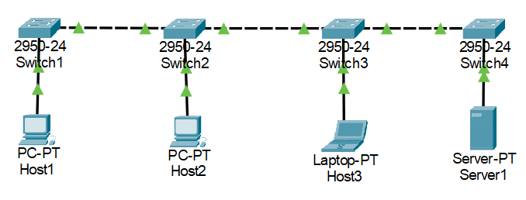

Addressing Table
Device | Interface | IPv4 Address | Subnet Mask | Switch
Host1 | NIC | 192.168.11.101 | 255.255.255.0 | Switch1
Host2 | NIC | 192.168.11.102 | 255.255.255.0 | Switch2
Host3 | NIC | 192.168.11.103 | 255.255.255.0 | Switch3
Server1 | NIC | 192.168.11.104 | 255.255.255.0 | Switch4

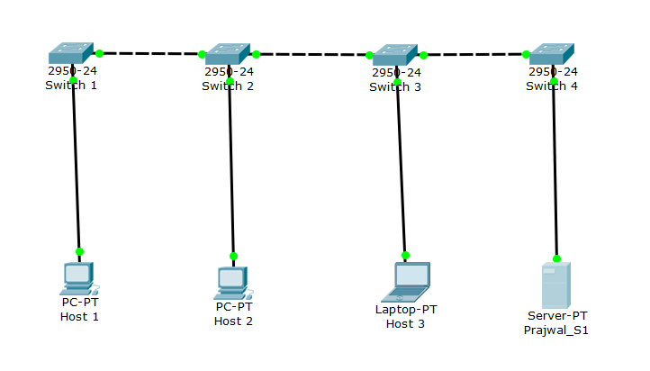
a) Design the given topology.
b) Assign the IP address to all nodes according to addressing table.
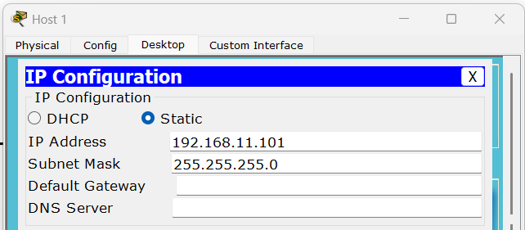

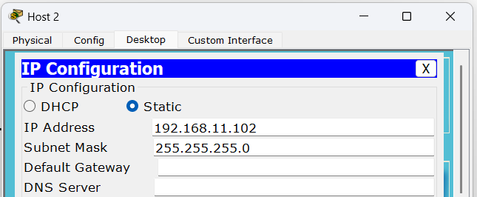

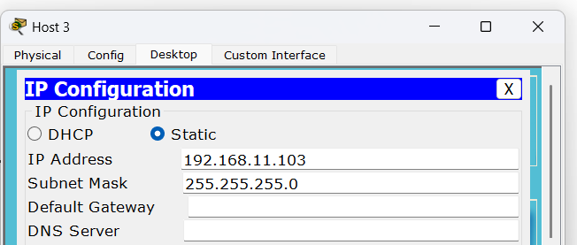

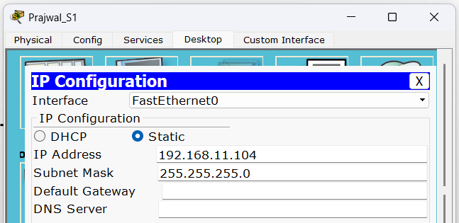

c) From the command prompt on each node, run the ping test and write the output.
- Can Host1 ping Server1?
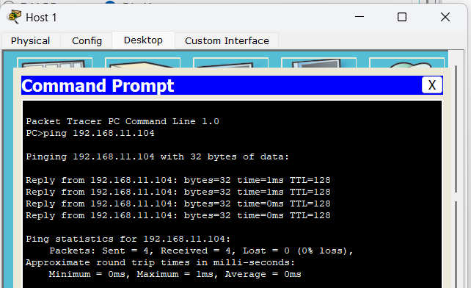

- Can Server1 ping Host3 and Host2?
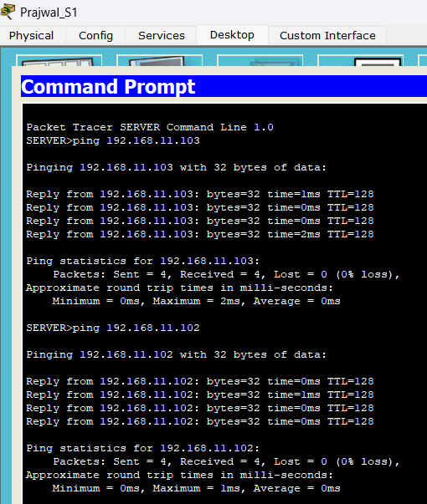

5.3 Ring Topology
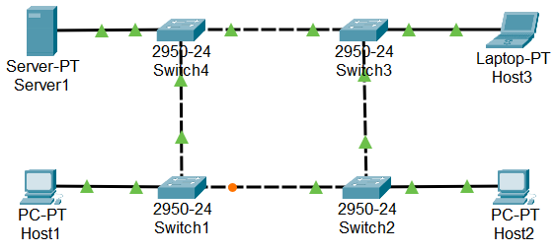

Addressing Table
Device | Interface | IPv4 Address | Subnet Mask | Switch
Host1 | NIC | 192.168.100.101 | 255.255.255.0 | Switch1
Host2 | NIC | 192.168.100.102 | 255.255.255.0 | Switch2
Host3 | NIC | 192.168.100.103 | 255.255.255.0 | Switch3
Server1 | NIC | 192.168.100.104 | 255.255.255.0 | Switch4

a) Design the given topology.
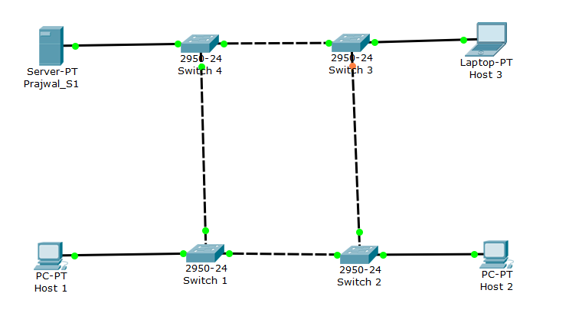
b) Assign the IP address to all nodes according to addressing table.
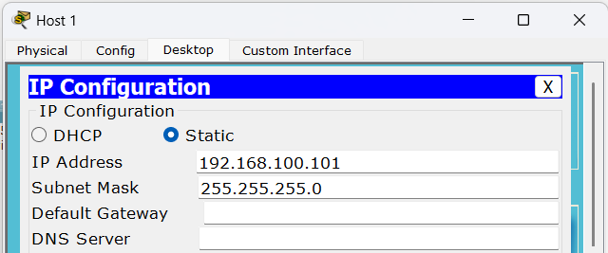

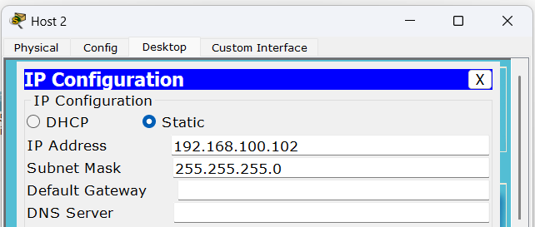

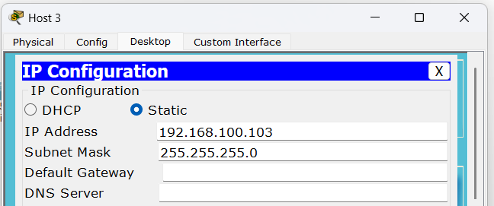

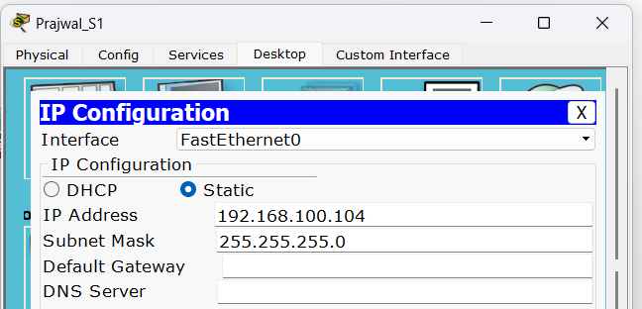

c) From the command prompt on each node, run the ping test and write the output.
- Can Host1 ping Host3?
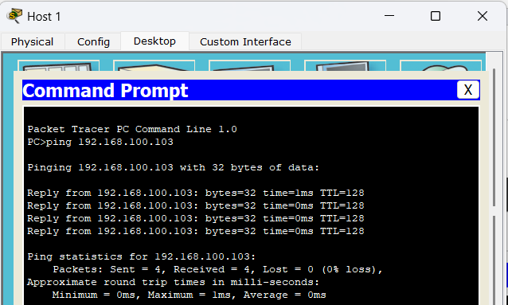

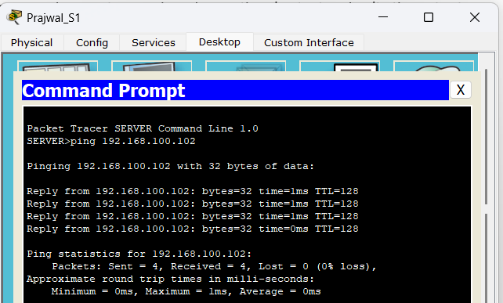
- Can Server1 ping Host2?
Task 6:- Creation of VLAN.
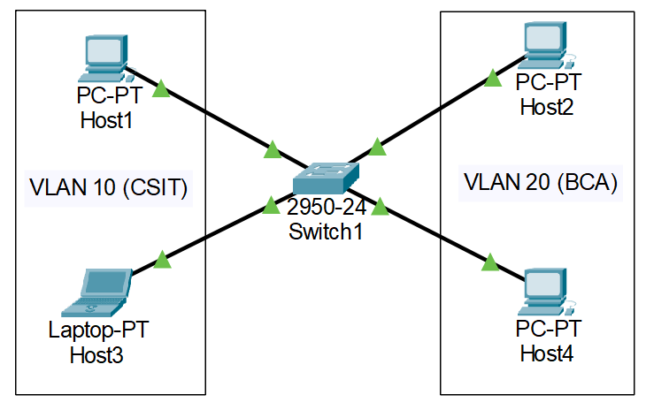

Addressing Table
Device | Interface | IPv4 Address | Subnet Mask | Switch Port | VLAN No | VLAN  Name | Link
Host1 | NIC | 172.17.10.21 | 255.255.255.0 | Fa0/1 | 10 | CSIT | Access
Host3 | NIC | 172.17.10.22 | 255.255.255.0 | Fa0/2 | 10 | CSIT | Access
Host2 | NIC | 172.17.10.23 | 255.255.255.0 | Fa0/11 | 20 | BCA | Access
Host4 | NIC | 172.17.10.24 | 255.255.255.0 | Fa0/12 | 20 | BCA | Access

a) Design the given topology.
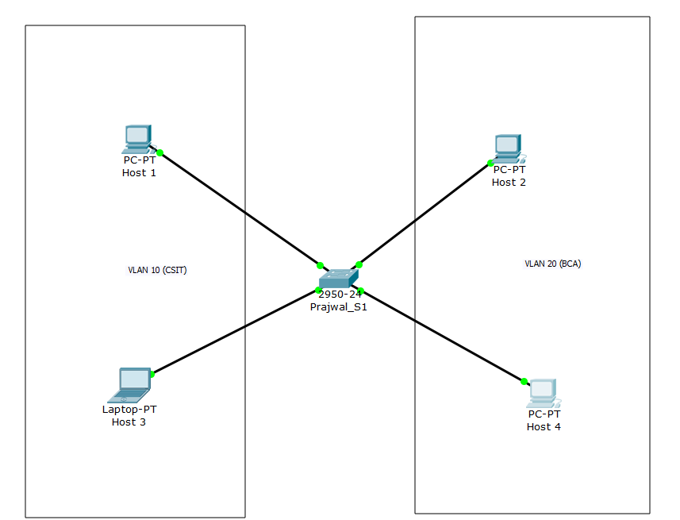

b) Assign the Layer 3 address (IP address) to all hosts.
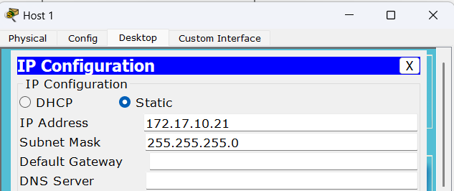

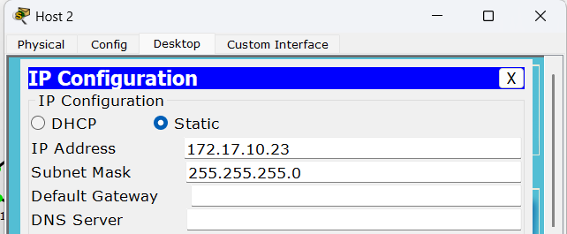

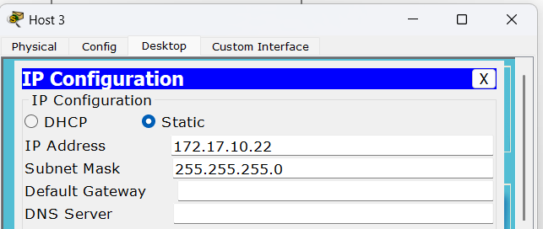

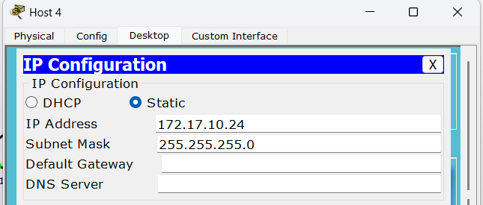

c) Configure the switch to create two VLANs.
- VLAN10 as CSIT
- VLAN 20 as BCA
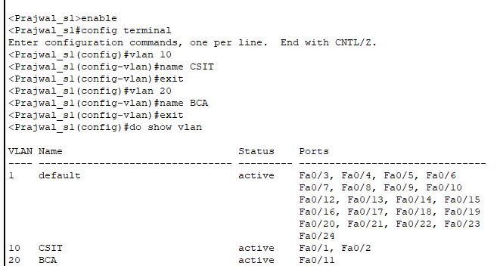

d) Assign VLANs to all the PC according to Addressing Table.
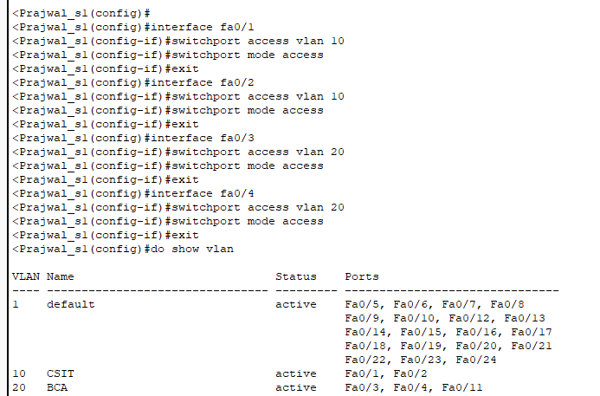
e) From the command prompt on each Host, do ping test between Hosts on the same and different
VLAN and write the output.
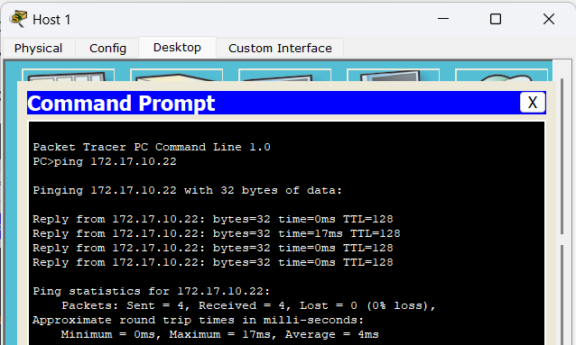
- Can Host1 ping Host3?

- Can Host2 ping Host4?
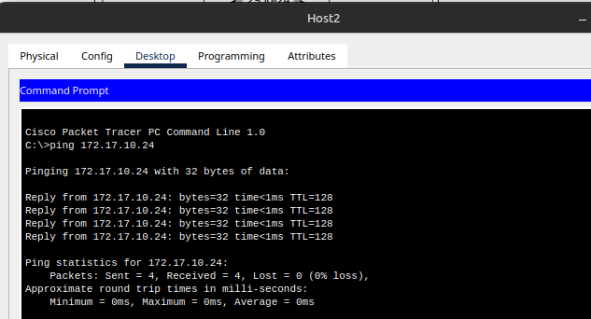
- Can Host1 ping Host2 and Host4?
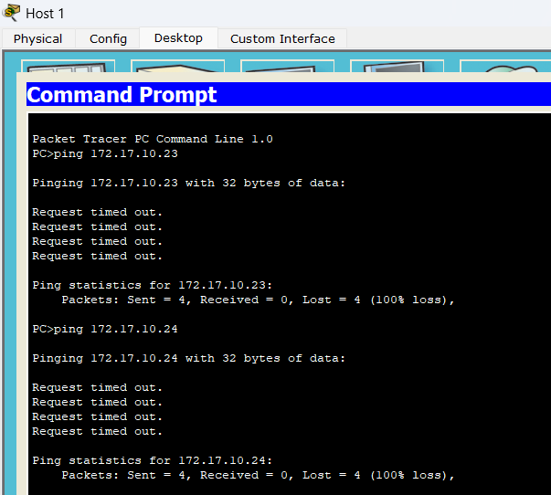

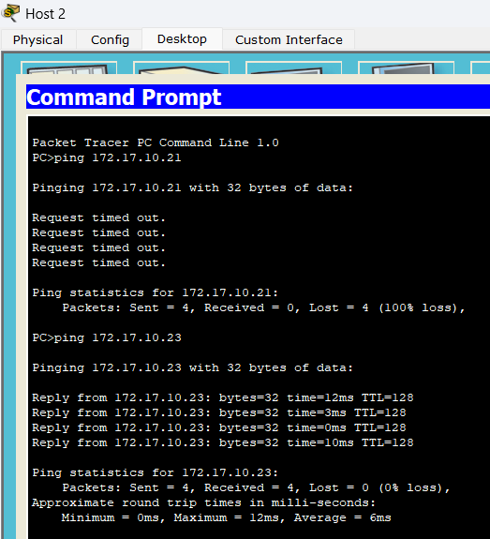
- Can Host2 ping Host1 and Host3?

Task 7:- Creation of VLAN Trunking.
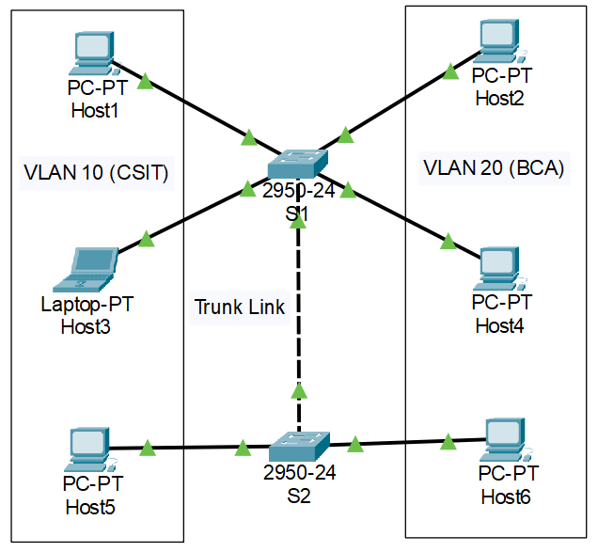

Addressing Table

Device | Interface | IPv4 Address | Subnet Mask | Switch Port | VLAN No | VLAN  Name | Link
Host1 | NIC | 172.17.10.21 | 255.255.255.0 | S1; Fa0/1 | 10 | CSIT | Access
Host3 | NIC | 172.17.10.22 | 255.255.255.0 | S1; Fa0/2 | 10 | CSIT | Access
Host2 | NIC | 172.17.10.23 | 255.255.255.0 | S1; Fa0/11 | 20 | BCA | Access
Host4 | NIC | 172.17.10.24 | 255.255.255.0 | S1; Fa0/12 | 20 | BCA | Access
Host5 | NIC | 172.17.10.25 | 255.255.255.0 | S2; Fa0/3 | 10 | CSIT | Access
Host6 | NIC | 172.17.10.26 | 255.255.255.0 | S2; Fa0/13 | 20 | BCA | Access
S1 | Fa0/24 | - | - | S2; Fa0/24 |  |  | Trunk

a) Design the given topology.
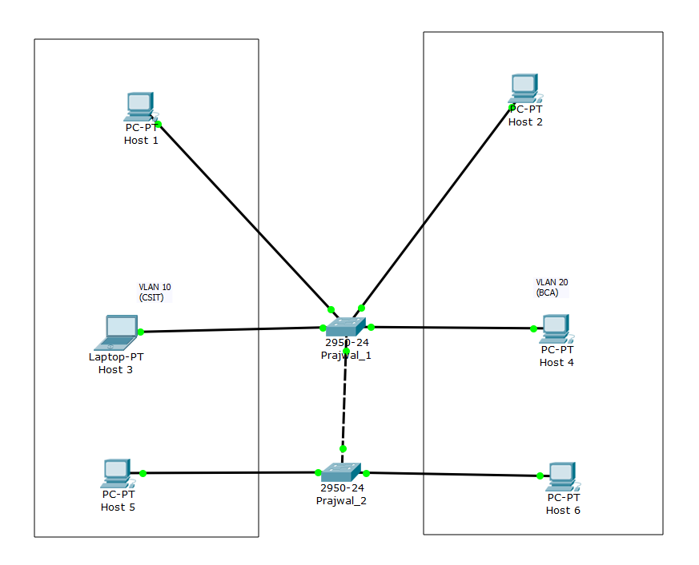

b) Assign the Layer 3 address (IP address) to all hosts.
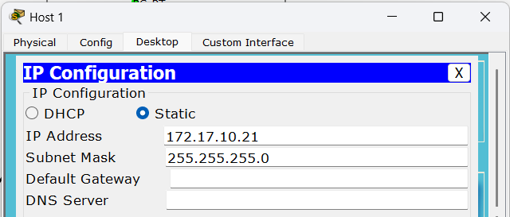

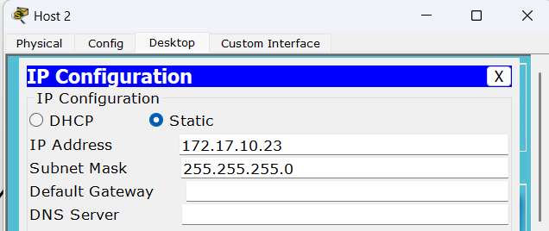

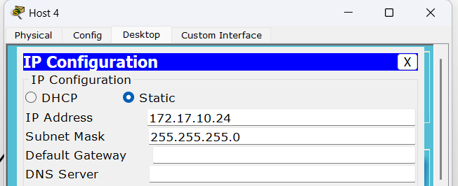
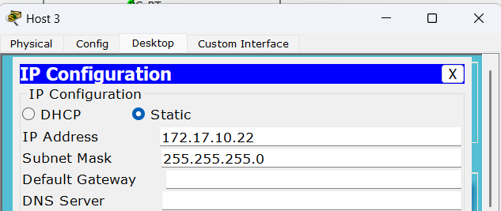
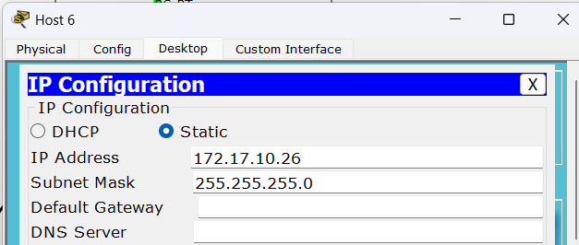
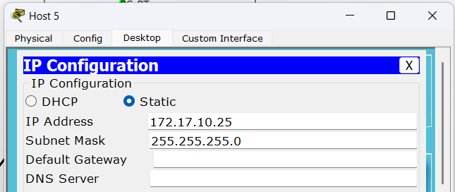

c) Configure the switch S1 and S2 to create two VLANs in each.
- VLAN10 as CSIT
- VLAN 20 as BCA
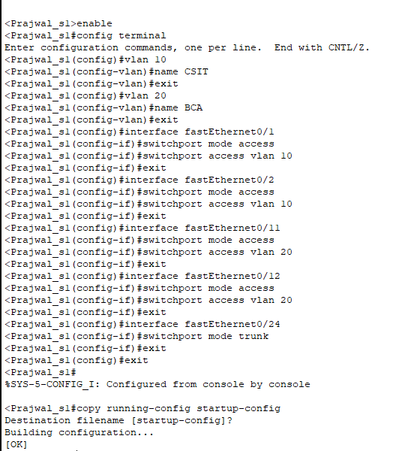

d) Assign VLANs to all the PC according to Addressing Table.
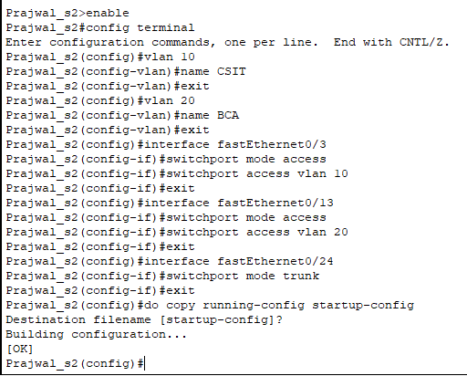

e) From the command prompt on each Host, do ping test between Hosts on the same and different
VLAN and write the output.
- Can Host1 ping Host3 and Host5?
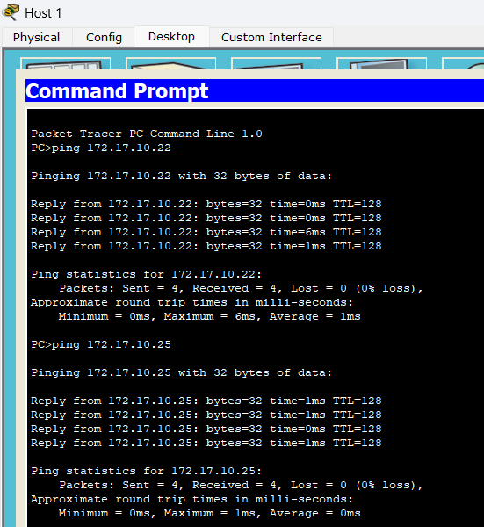

- Can Host2 ping Host4 and Host6?
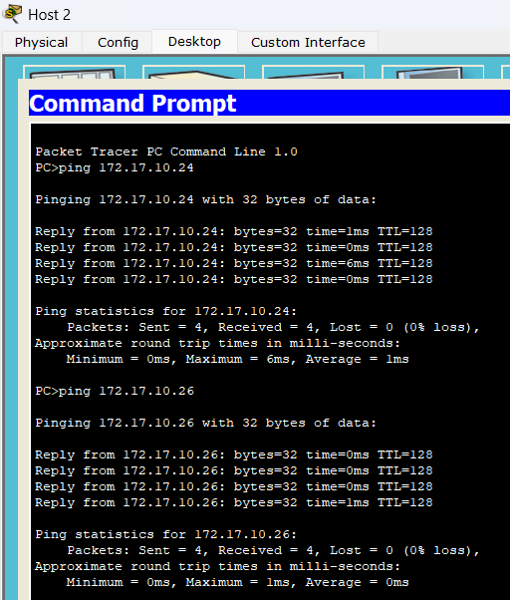

- Can Host6 ping Host1?
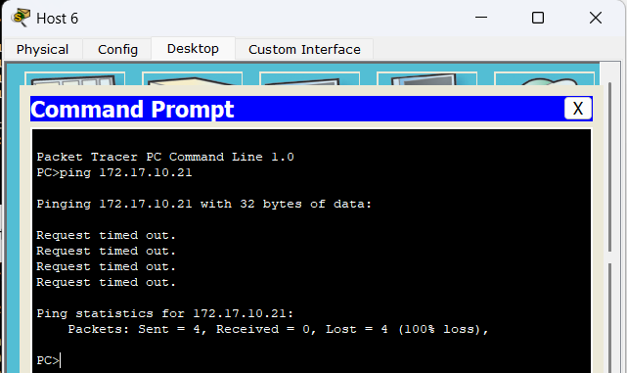

- Can Host5 ping Host4?
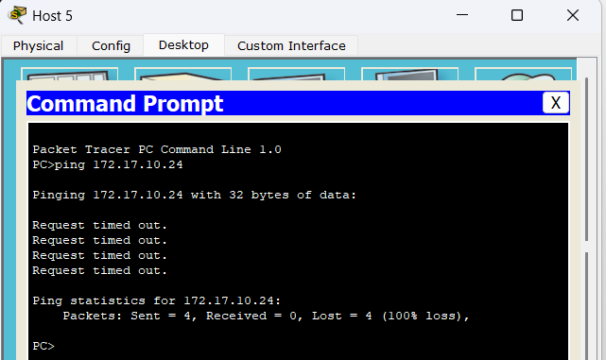

Task 8:- Implementation of Static Routing configuration.
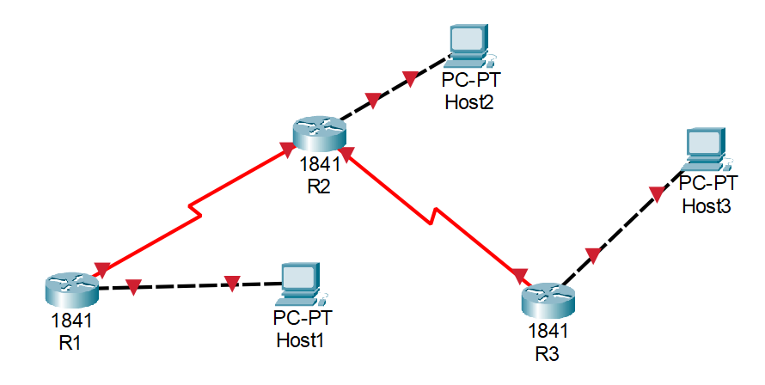

Addressing Table
Device | Interface | IPv4 Address | Subnet Mask | Gateway | Link Ports
Host1 | NIC | 172.16.3.100 | 255.255.255.0 | 172.16.3.1 | R1; fa0/0
Host2 | NIC | 172.16.1.100 | 255.255.255.0 | 172.16.1.1 | R2; fa0/0
Host3 | NIC | 192.168.2.100 | 255.255.255.0 | 192.168.2.1 | R3; fa0/0
R1 | fa0/0 | 172.16.3.1 | 255.255.255.0
R1 | se 0/0/0 | 172.16.2.1 | 255.255.255.0 |  | R2; se 0/0/0
R2 | fa0/0 | 172.16.1.1 | 255.255.255.0
R2 | se 0/0/0 | 172.16.2.2 | 255.255.255.0 |  | R1; se 0/0/0
R2 | se 0/0/1 | 192.168.1.1 | 255.255.255.0 |  | R3; se 0/0/0
R3 | fa0/0 | 192.168.2.1 | 255.255.255.0
R3 | se 0/0/0 | 192.168.1.2 | 255.255.255.0 |  | R2; se 0/0/1

a) Design the given topology.
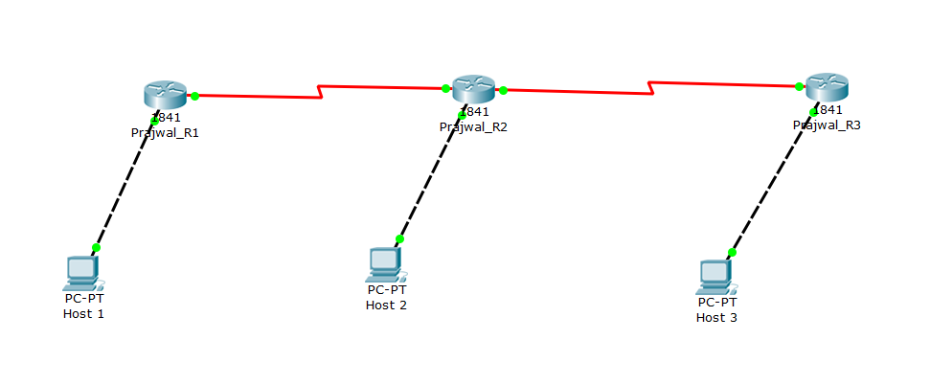

b) Assign the IP address to all hosts and Routers according to Addressing Table.
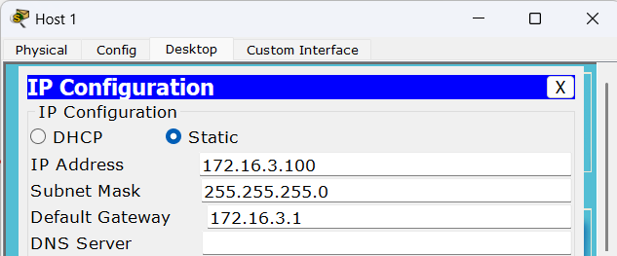

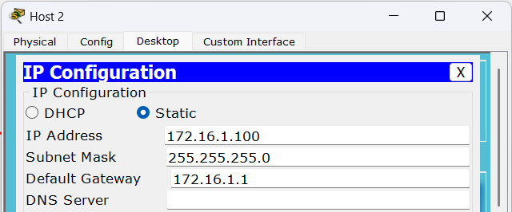

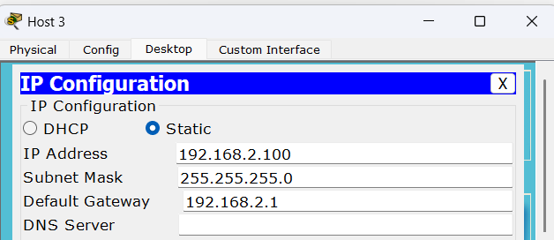

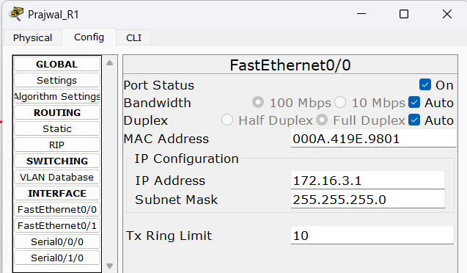

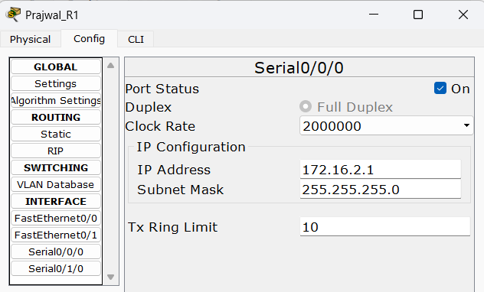

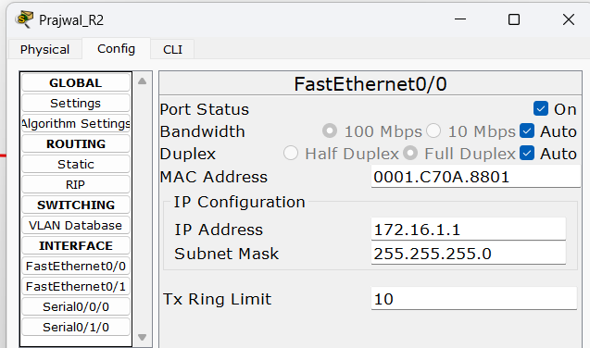

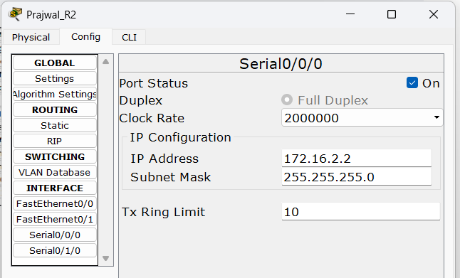

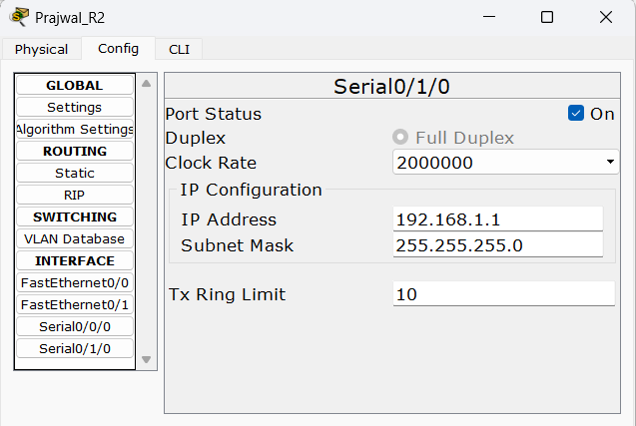

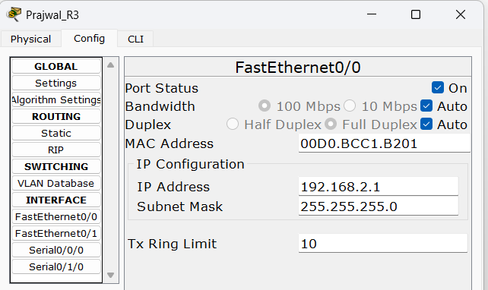

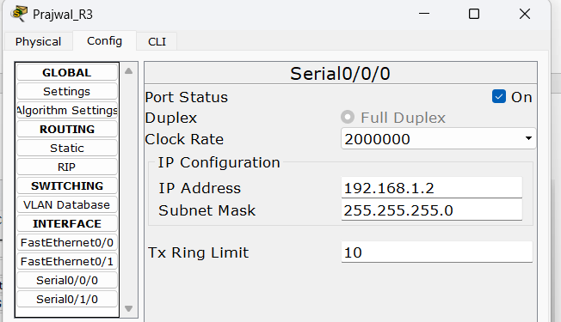

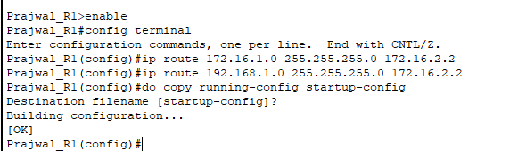
c) Configure the routers with static route.
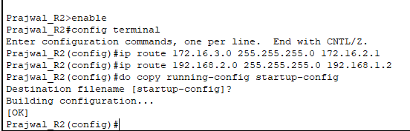

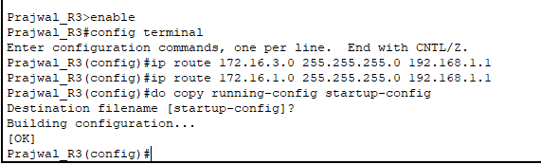

d) From the command prompt on each host, ping between hosts. Write the output.
- Can Host1 ping Host2 and Host3?
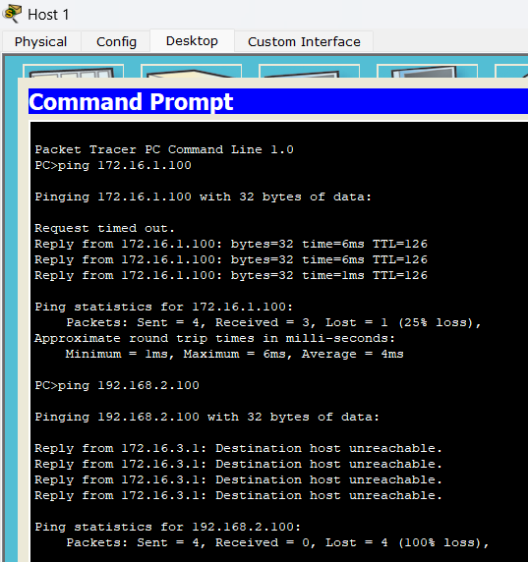

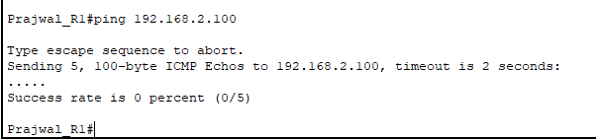
- Can router R1 ping router Host3?

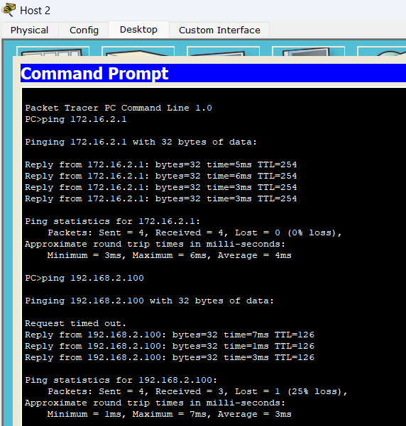
- Can Host2 ping router R1 and Host3?

Task 9:- Implementation of dynamic routing (RIP) configuration.
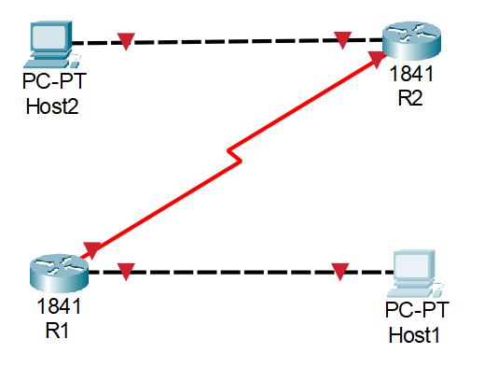

Addressing Table
Device | Interface | IPv4 Address | Subnet Mask | Gateway | Link Ports
Host1 | NIC | 172.16.3.10 | 255.255.0.0 | 172.16.3.1 | R1; fa0/0
Host2 | NIC | 172.18.1.10 | 255.255.255.0 | 172.18.1.1 | R2; fa0/0
R1 | fa0/0 | 172.16.3.1 | 255.255.0.0
R1 | se 0/0/0 | 172.17.2.1 | 255.255.255.252 |  | R2; se 0/0/0
R2 | fa0/0 | 172.18.1.1 | 255.255.255.0
R2 | se 0/0/0 | 172.17.2.2 | 255.255.255.252 |  | R1; se 0/0/0

a) Design the given topology.
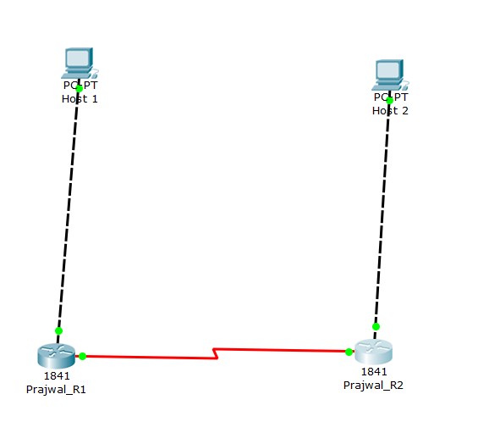

b) Assign the IP address to all PCs and Routers according to Addressing Table.
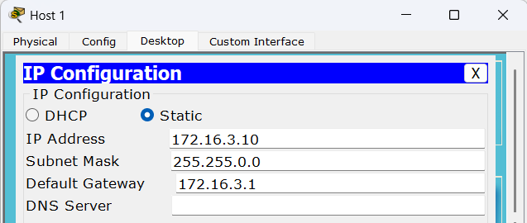

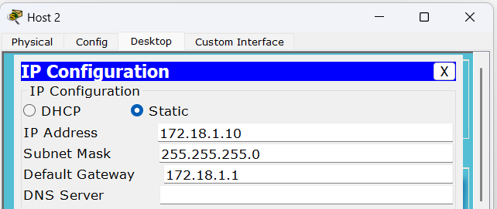

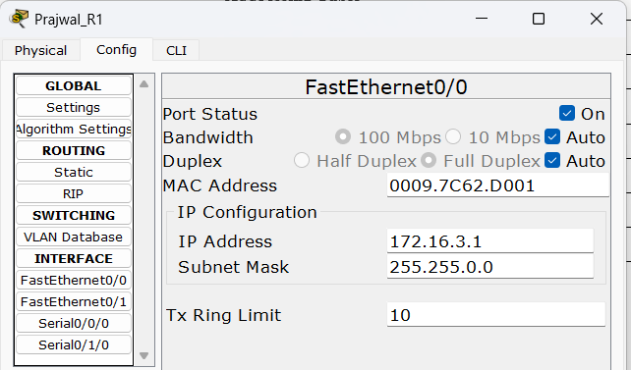

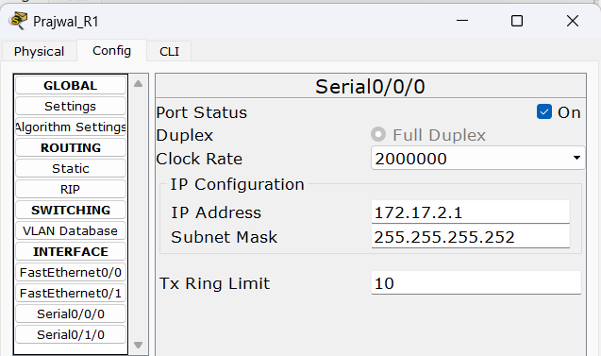

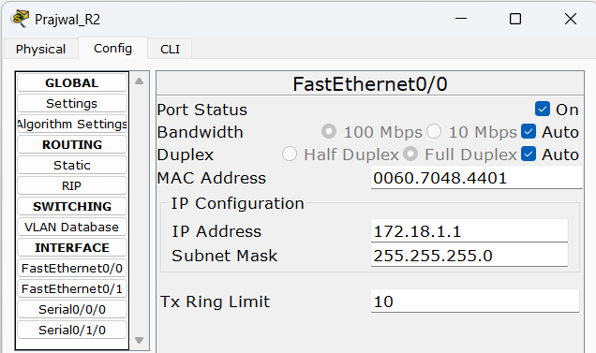

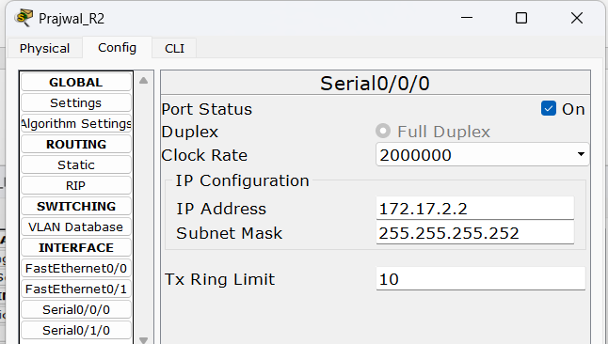

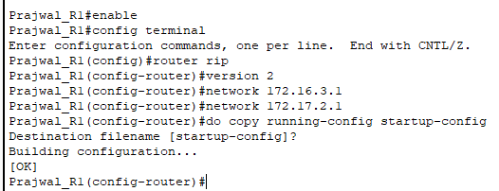
c) Configure the routers with RIPv2.
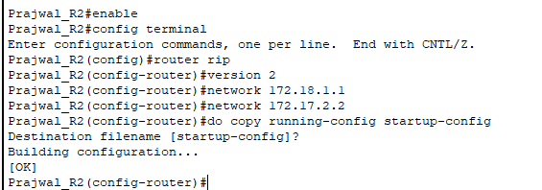

d) From the command prompt on each host, ping between hosts and routers. Write the output.
- Can host1 ping host2?
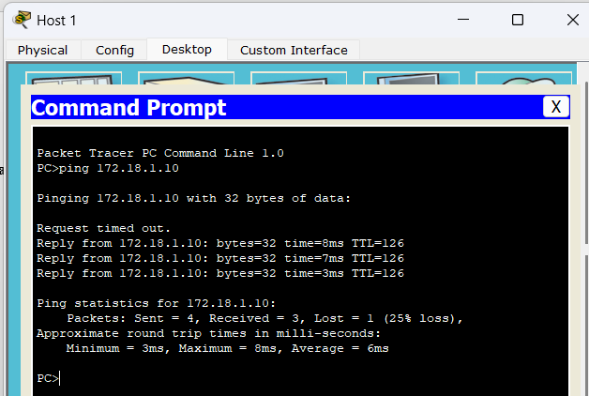

- Can router R1 ping router R2?
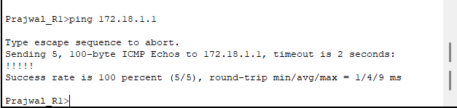

- Can host2 ping router R1?
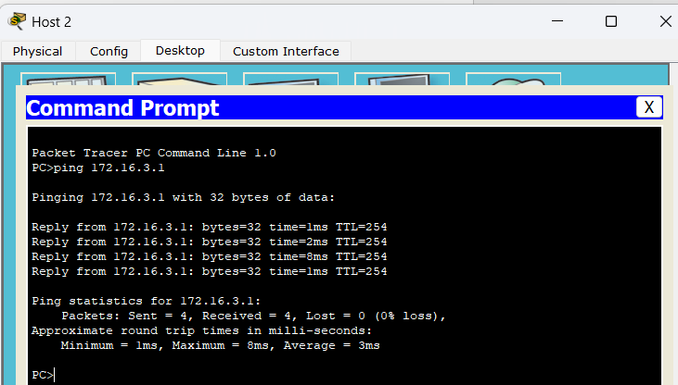
Task 10:- Implementation of dynamic routing (OSPF) configuration.

Addressing Table
Device | Interface | IPv4 Address | Subnet Mask | Gateway | Link Ports
Host1 | NIC | 172.16.3.10 | 255.255.0.0 | 172.16.3.1 | R1; fa0/0
Host2 | NIC | 172.18.1.10 | 255.255.255.0 | 172.18.1.1 | R2; fa0/0
R1 | fa0/0 | 172.16.3.1 | 255.255.0.0
R1 | se 0/0/0 | 172.17.2.1 | 255.255.255.252 |  | R2; se 0/0/0
R2 | fa0/0 | 172.18.1.1 | 255.255.255.0
R2 | se 0/0/0 | 172.17.2.2 | 255.255.255.252 |  | R1; se 0/0/0

a) Design the given topology.
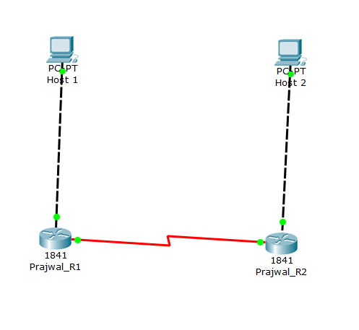

b) Assign the IP address to all PCs and Routers according to Addressing Table.
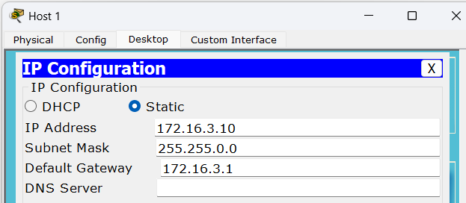

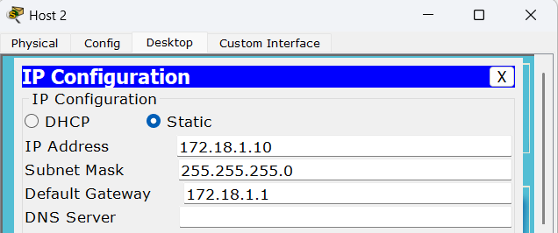

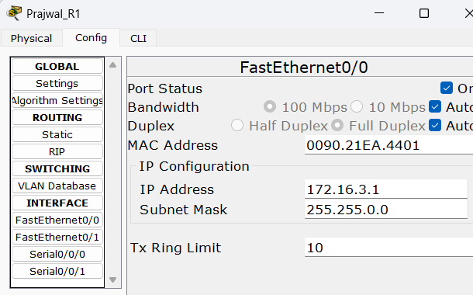

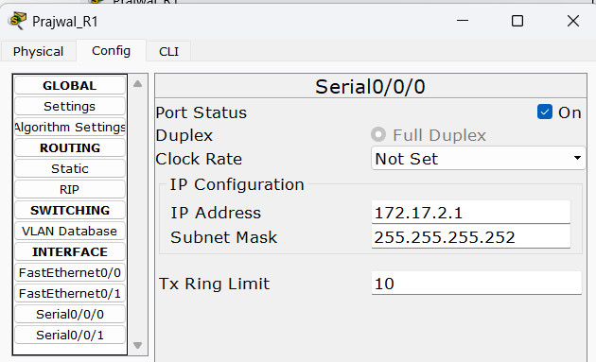

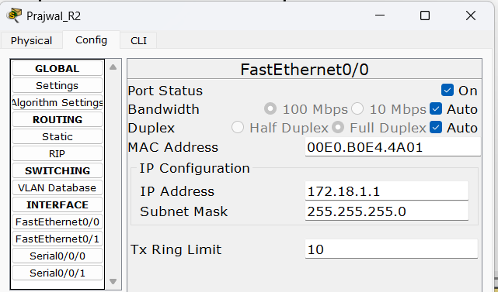

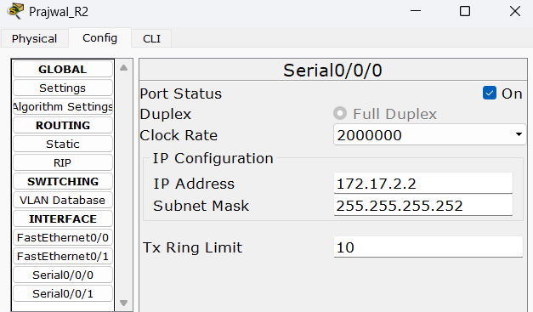

c) Configure the routers with OSPF in single area i.e., area 1.
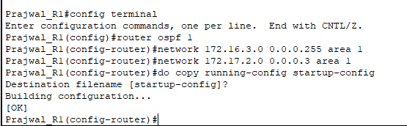

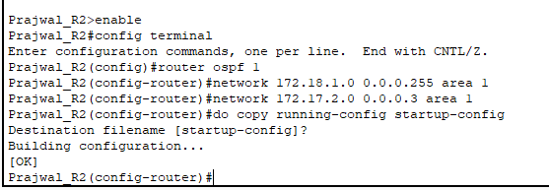

d) From the command prompt on each host, ping between hosts and routers. Write the output.
- Can host1 ping host2?
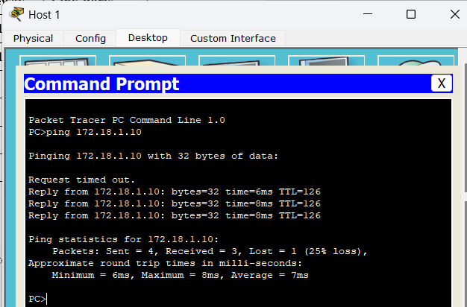

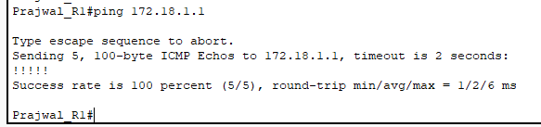
- Can router R1 ping router R2?

- Can host2 ping router R1?
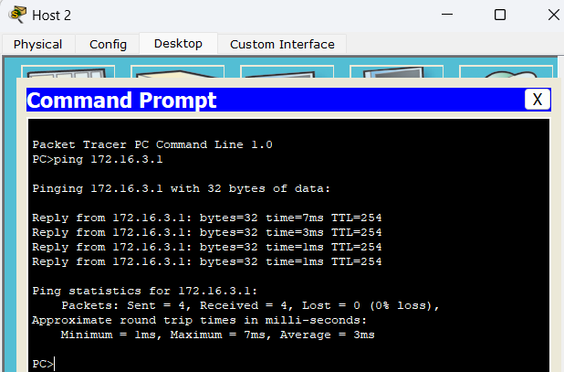

Task 11:- Configure DNS, DHCP, FTP and Web Server.

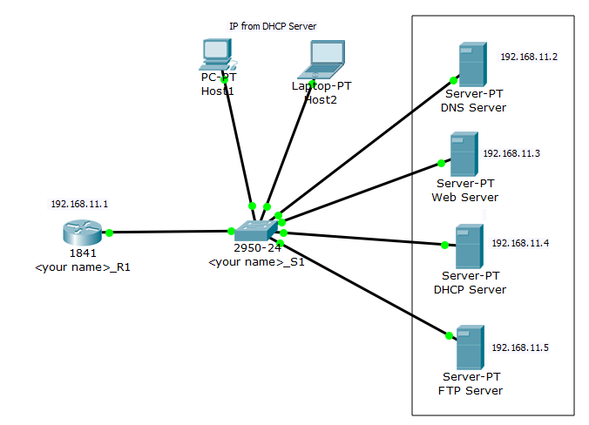

Addressing Table
Device | Interface | IPv4 Address | Subnet Mask | Gateway | Remarks
Host1 | NIC | From DHCP server
Host2 | NIC
R1 | fa0/0 | 192.168.11.1 | 255.255.255.0
DNS Server | NIC | 192.168.11.2 | 255.255.255.0 | 192.168.11.1
Web Server | NIC | 192.168.11.3 | 255.255.255.0 | 192.168.11.1 | www.cnlab.local
DHCP Server | NIC | 192.168.11.4 | 255.255.255.0 | 192.168.11.1 | IP pool = 20
FTP Server | NIC | 192.168.11.5 | 255.255.255.0 | 192.168.11.1 | ftp.Cnlab.local
a) Design the given topology.
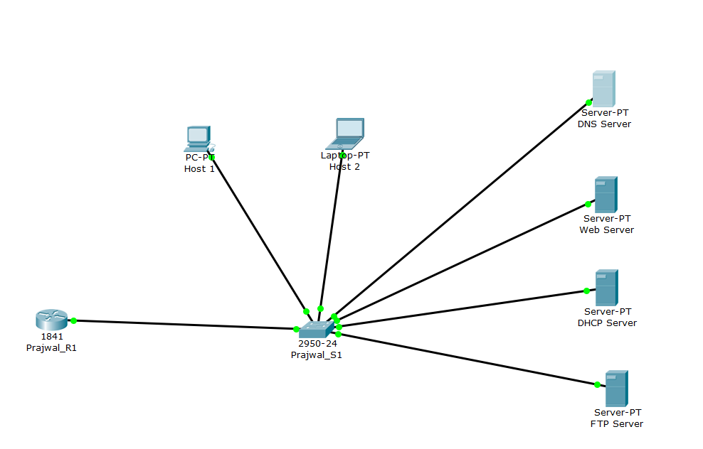

b) Assign the IP address to Router and all servers according to Addressing Table.
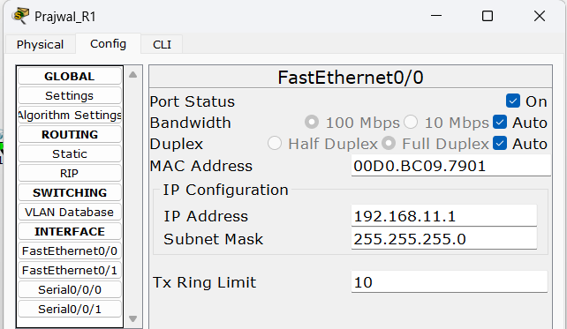

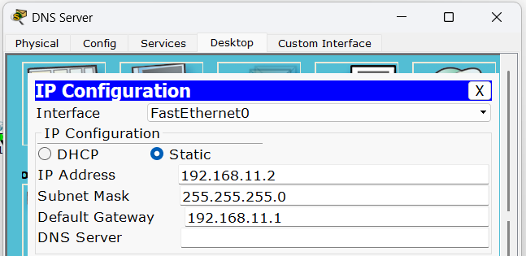

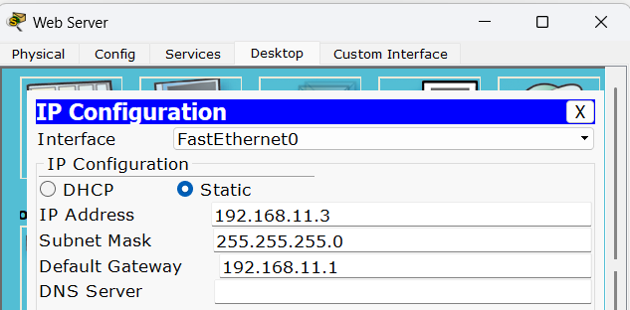

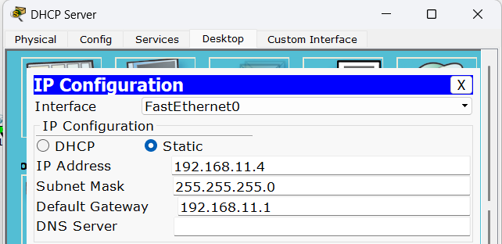

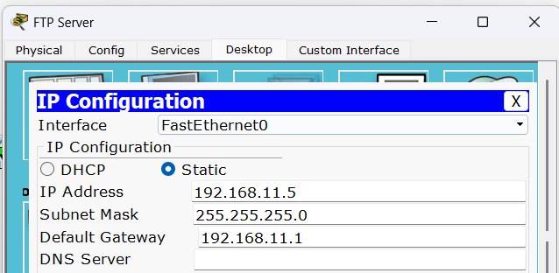
c) Configure the respective servers.
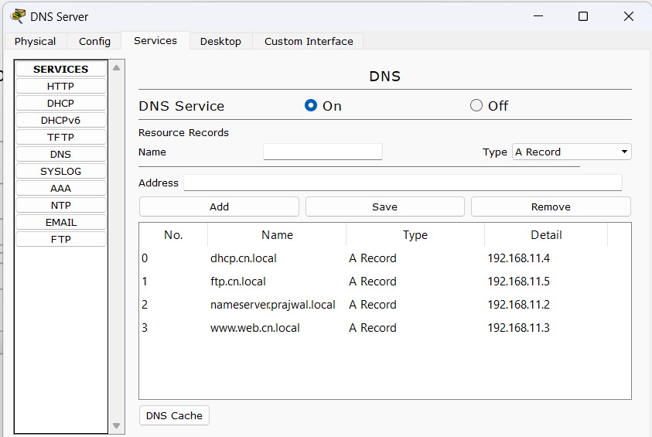

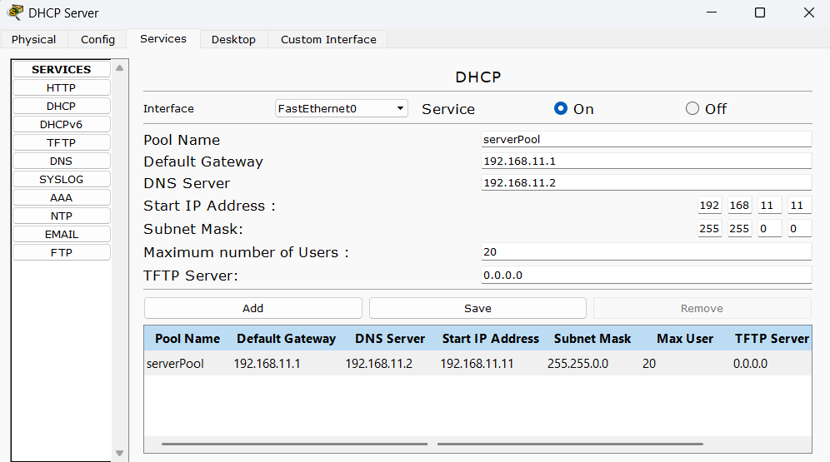

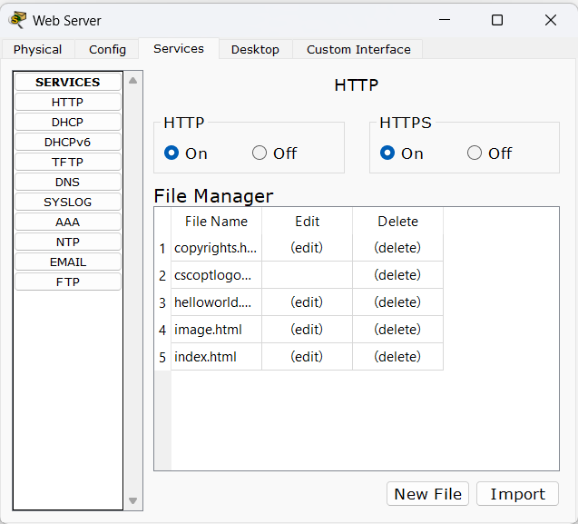

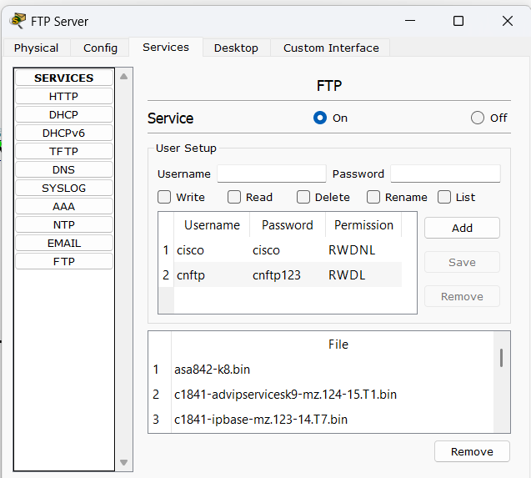

d) Assign the IP address to all Hosts automatically using DHCP server.
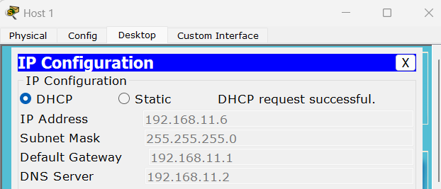

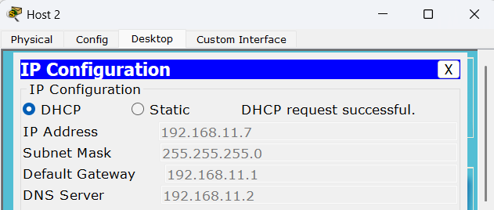

e) Verify all the configurations.
